AQA Mock Exams Analyser – Technical Guidance
The Mock Exams Analyser is designed to help students in evaluating and assessing their own performance.
Most of the spreadsheet is pre-populated with a range of information from the November examinations. The two red areas on the main page require students to input their:
- mark for each question in the test
- target grade for the Unit
Maximum mark for each part of the question
Students enter their own mark here

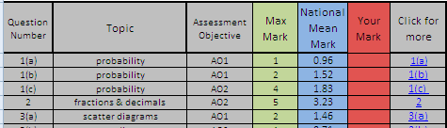
Mean mark of the candidates who took the live exam

The topic area and Assessment Objective of each question is identified

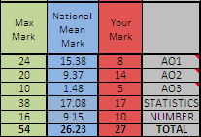

Once this information is provided, the two summary boxes and the graph will show students how they have performed on the topic areas, as well as the Assessment Objectives. The grade they would have got is provided, and they can click to view how many UMS points they would have scored.

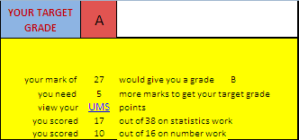
Students will get their performance summary displayed here

Students can then review each question in the exam, along with the relevant extract from the mark scheme, any comments from the report on the examination and an answer that is worth full marks. These can be accessed using the “click for more” links to the right of the “your mark” column

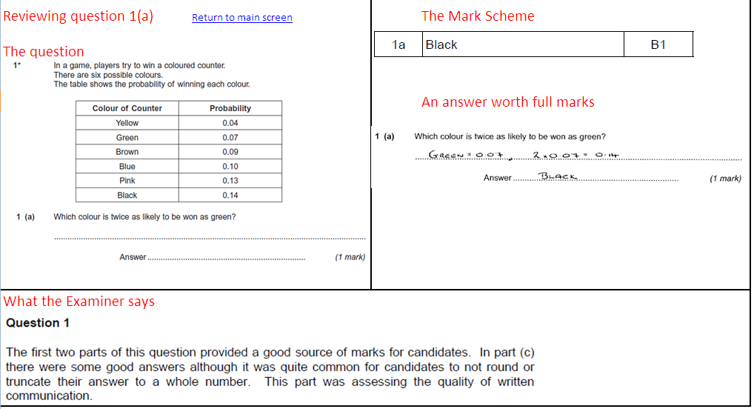
Important note:
We have made the decision not to include the Allowed Grade E on the Higher tier. That Grade is designed as a safety net for students who narrowly miss Grade D, and we would not encourage students working at this level to attempt the Higher tier.

This is a trial service that we hope will be of use to you and your students. If you like it, or have any suggested improvements, let us know and we'll produce another one for the March examinations.

