Practice Questions
Level 3 Mathematical Studies 1350

Statistical techniques
April 2018

F

1 Asif is researching expenditure per person on health through the world.
He collects data from a sample of 11 countries across the world.

The table shows the gross national income per person and the expenditure per person on health.

Country | Gross national income per person,  US dollars (x) | Expenditure per person on health,  US dollars (y)
Afghanistan | 1 380 | 55.9
Bosnia and Herzegovina | 9 350 | 492.6
Canada | 41 390 | 5629.7
Greece | 25 110 | 2864.2
Kenya | 1 680 | 36.2
Mauritius | 14 350 | 510.0
Norway | 61 390 | 8987.3
Swaziland | 4 900 | 264.8
United Arab Emirates | 41 550 | 1639.9
United Kingdom | 36 560 | 3608.6
Uruguay | 14 450 | 1104.9

- For the above table of data, use gross national income per person, (x), and expenditure per person on health, (y), to plot a scatter graph on the grid opposite.
[2 marks]
- Use your calculator to find:

- the mean gross national income per person, $\overline{x}$;
[1 mark]

- the mean expenditure per person on health, $\overline{y}$;
[1 mark]

- the product moment correlation coefficient, r.
[1 mark]

- Interpret the value of r found in part (b) (iii) in the context of this question.
[1 mark]

- (i) Find the equation of the line of best fit of y on x. Give any numerical values correct to
three significant figures.
[3 marks]

(ii) Draw the line of best fit on your scatter graph.
[3 marks]

(iii) Interpret the gradient of the line of best fit in the context of this question.
[2 marks]

Answer space for question 1

Answer space for question 1

Answer space for question 1

2 Sophia has picked 6 kilograms of damsons growing wild in the countryside. She intends to make jam with the damsons. She will donate the jam to her local youth club which will sell the jam on its market stall to raise funds.

To make the jam, Sophia will need a kilogram of sugar and 400 milliliters of water for each kilogram of damsons. She fills 33 jars, and each jar of the damson jam will be sold for £2.85.
The sugar costs 97p per kilogram and Sophia will be reimbursed for this cost when the jam is sold.

- (i) Calculate how much money the youth club will make from selling the jam, assuming that all 33 jars are sold and that Sophia has been reimbursed for the cost of the sugar.
[3 marks]

- The contents of each jar follow a normal distribution with mean weight 360 grams and a standard deviation 8 grams.

(i) Find the probability that the weight of jam in a jar is more than 366 grams.
[4 marks]

(ii) The label on the jar indicates that the minimum weight of the jam in the jar is
340 grams. Can this claim be justified? Show your working clearly.
[5 marks]

Answer space for question 2

Answer space for question 2

Answer space for question 2
Answer space for question 2

3 The table shows 9 countries who took part in the London Olympic Games in 2012.
It shows the population of each country and the number of medals won.

Country | Population (millions) | Number of gold medals won
Great Britain | 62.3 | 29
Hungary | 10 | 8
New Zealand | 4.4 | 6
Spain | 46.2 | 3
Romania | 19 | 2
Switzerland | 7.9 | 2
Georgia | 4.5 | 1
Tunisia | 10.7 | 1
Bahamas | 0.4 | 1

- For the above table of data, use Population (millions) (x) and Number of gold medals won (y) to plot a scatter graph on the grid opposite.
[2 marks]

- Use your calculator to find:

(i) the mean population, $\overline{x}$;
[1 mark]

(ii) the mean number of gold medals won, $\overline{y}$;
[1 mark]

(iii) the product-moment correlation coefficient, r.
[1 mark]

(c) Interpret your value of r found in part (b) in the context of this question.
[1 mark]

(d) (i) Calculate the equation of the line of best fit of y on x. Give any numerical values
correct to three significant figures.
[3 marks]

(ii) Plot the line of best fit on your scatter graph.
[3 marks]

(e) (i) Canada has a population of 34.8 million. Use your equation or your line of best fit to
estimate the number of gold medals that Canada should have won.
[2 marks]

(ii) In fact, Canada won one gold medal. Comment on this result.
[1 mark]

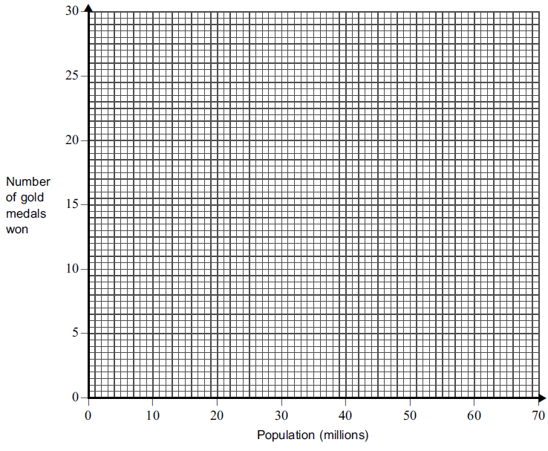
Answer space for question 3

Answer space for question 3

Answer space for question 3

4 (a) Meredith wants to cook a pheasant for dinner. The butcher asks Meredith to choose
an oven-ready pheasant.

Assume that the weight of an oven-ready pheasant follows a normal distribution with a mean of 800 grams and a standard deviation of 80 grams.

(i) Find the probability that Meredith’s pheasant weighs less than 920 grams.
[3 marks]

(ii) Find the probability that Meredith’s pheasant weighs between 780 grams and
920 grams.
[4 marks]

(b) The butcher wishes to advertise the pheasants as follows: “90% of our pheasants are
greater than ....... grams’’

What should this weight be?
[4 marks]

Answer space for question 4
Answer space for question 4

Answer space for question 4

Answer space for question 4

5 An experiment was undertaken to collect information on the burning of a specific
type of wood as a source of energy. At given fixed levels of the wood’s moisture
content, x per cent, its corresponding calorific value, y MWh /tonne, on burning was
determined. The results are shown in the table.

x | 5 | 10 | 15 | 20 | 25 | 30 | 35 | 40 | 45 | 50 | 55 | 60 | 65
y | 5.2 | 4.7 | 4.3 | 4.0 | 3.2 | 2.8 | 2.5 | 2.2 | 1.8 | 1.5 | 1.3 | 1.0 | 0.6

- Calculate the equation of the least squares regression line of y on x, giving your
answer in the form y = a + bx.
[5 marks]
- Interpret, in context, your values for a and b.
[3 marks]
(c) Use your equation to estimate the wood’s calorific value when it has a moisture
content of 27 per cent.
[2 marks]

Answer space for question 5

Answer space for question 5

Answer space for question 5

6 The weight of sand in a bag can be modelled by a normal random variable with
unknown mean m kilograms and known standard deviation 0.4 kilograms.

The sand in each of a random sample of 25 bags from a large batch is weighed.
The mean weight of sand in these 25 bags is found to be 19.9kg.

- Construct a 98% confidence interval for the mean weight of sand in bags in the
batch.
[4 marks]

(b) Hence comment on the claim that bags in the batch contain an average of 20kg of
sand.
[2 marks]

Answer space for question 6

Answer space for question 6

7 The table shows the maximum weight, y_{A} grams, of Salt A that will dissolve in
100 grams of water at various temperatures, x ºC

x | 10 | 15 | 20 | 25 | 30 | 35 | 40 | 45 | 50 | 60 | 70 | 80
yA | 20 | 35 | 48 | 57 | 77 | 92 | 101 | 111 | 121 | 137 | 159 | 182

(a) Calculate the equation of the least squares regression line of y_{A} on x.
[4 marks]
(b) The data in the above table are plotted on the scatter diagram on the opposite page.
Draw your regression line on this scatter diagram.
[2 marks]

(c) For water temperatures in the range 10 ºC to 80 ºC, the maximum weight, y_{B} grams,
of Salt B that will dissolve in 100 grams of water is given by the equation
y_{B} = 60.1 + 0.255x

(i) Draw this line on the scatter diagram.
[2 marks]
(ii) Estimate the water temperature at which the maximum weight of Salt A that will dissolve in 100 grams of water is the same as that of Salt B.
[1 mark]
(iii) For Salt A and Salt B, compare the effects of water temperature on the maximum weight that will dissolve in 100 grams of water. Your answer should identify two distinct differences.
[2 marks]
Answer space for question 7

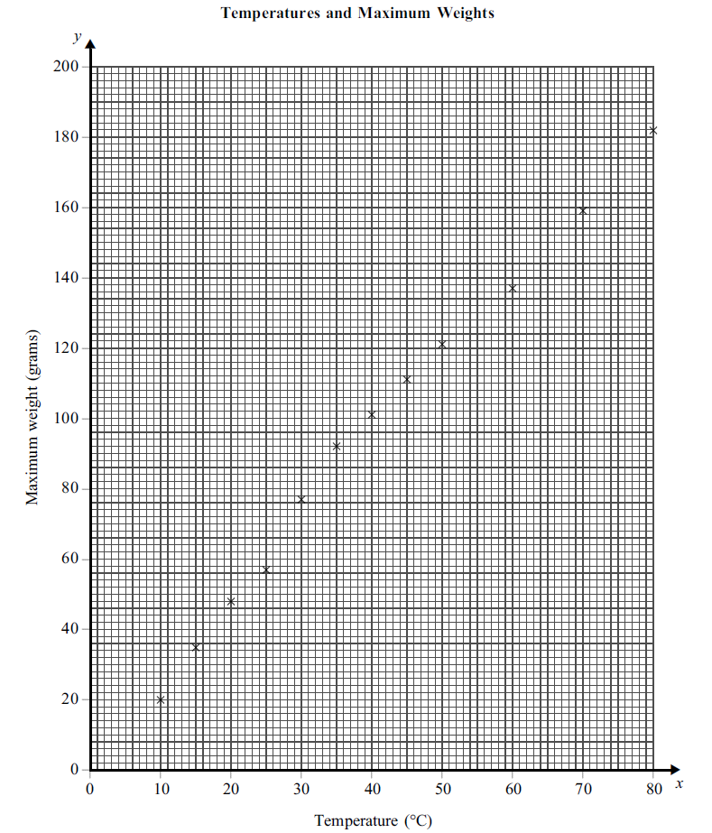

Answer space for question 7
Answer space for question 7
8 Sam has three hives of honeybees in his back garden. In a particular year, he is lucky with the weather and there is a surplus of honey, with the hives producing 16kg, 20kg and 14.5kg respectively. He can sell the honey in jars for £3.50 each.
The weight of honey in a jar follows a normal distribution with a mean of 460g and a standard deviation of 15g.

- How many jars containing 460g of honey can be filled?
[2 marks]
(b) If Sam sells 80% of his jars of honey, what income will he receive?
[2 marks]
(c) Find the probability that the weight of honey in a jar is more than 472g.
[4 marks]
(d) Labels on the jars indicate the nominal weight of honey in the jars is 454g.
Sam performs calculations and realises that approximately 34.5% of jars may contain less than the nominal weight of 454g. Sam wants to reduce the probability that a jar of honey contains less than the nominal weight of 454g.
If the standard deviation remains at 15g, what would the new mean value need to be so that 90% of the jars have a weight above 454g (the nominal value)?
[4 marks]

Answer space for question 8
Answer space for question 8
Answer space for question 8
Answer space for question 8

9 A large number of people attend a music festival.

Festival organisers decide to survey a sample of people to find out what they think
about buying tickets on-line.
They will interview every 50th person as they leave the festival arena.
(a) Write down the name of this sampling method.
[1 mark]

Answer ...........................................................

(b) Suggest two practical difficulties in conducting the interviews.
[2 marks]

Difficulty 1 ........................................................................................................................

.........................................................................................................................................

Difficulty 2 ........................................................................................................................

.........................................................................................................................................

(c) Describe the main difference between the method of sampling used and a quota
sample.
[1 mark]
............................................................................................................................................
............................................................................................................................................
............................................................................................................................................

10 A local council delivers leaflets to 200 houses in one area of town.
The leaflets explain changes to be made to weekly refuse collections in the area.
After the delivery of the leaflets, Steve, a council official, suggests calling on a sample of the houses to check residents’ views on the changes.

(a) (i) Describe in detail how Steve could select a simple random sample of 30 houses from this area.
[4 marks]

(a) (ii) Explain why this method of sample selection is likely give an unbiased sample.
[1 mark]
(b) Suggest two practical difficulties Steve might have in carrying out this survey.
[1 mark]

(c) Another council official suggests selecting a sample of 30, stratified by street.
The houses in the area covered consist of
45 houses in North Street
82 houses in West Street
60 houses in South Street
13 houses in East Street.

How many houses from each street should be chosen?
..................................…………...….…….....…………………………………………….…..
..................................…………...….…….....…………………………………………….…..
..................................…………...….…….....…………………………………………….…..

North Street …………………………………………….
West Street …………………………………………….
South Street …………………………………………….
East Street …………………………………………….

[4 marks]

END OF QUESTIONS

